3-D Printed Jewelry & accessories

**Business Idea**—The business idea is to provide nice and affordable jewelry for all ages at an accessible price. Also provide a nice design which will attract people while keeping the price down. We will also provide quality good create nice looking design that will attract our customers. We not will only provide for luxurious piece but also affordable ones that will make those who buy them be happy.

**Competition**— Looking around the area, our main competition would be Pugster Inc. as they provide cheap and affordable jewelry to the public.

**Role of IS**—The use of information system will be to Collect Data and applying by understanding the demography of people that spend certain amount of their income in jewels/jewelry. Get information about the competition and how they perform around that area. Collect data of the expenses require to maintain the business. The need of the client and what they would prefer to see in this store.

**Revenue—**

**Customers—**

**Location Analytics I—** looking at the median average disposable income. This will allow us to know where it would be better to open a store. Also, setting not getting to close to others keeping a good distance so our business doesn’t conflict with the others.

**Location Analytics II— (**This is a not well done sample just a screen shot… need to work it out more…trying to understand how to use it… I should watch some videos.) This use the Ave disposable income and location of Jewelry stores to see where in Pasadena would be a good idea.

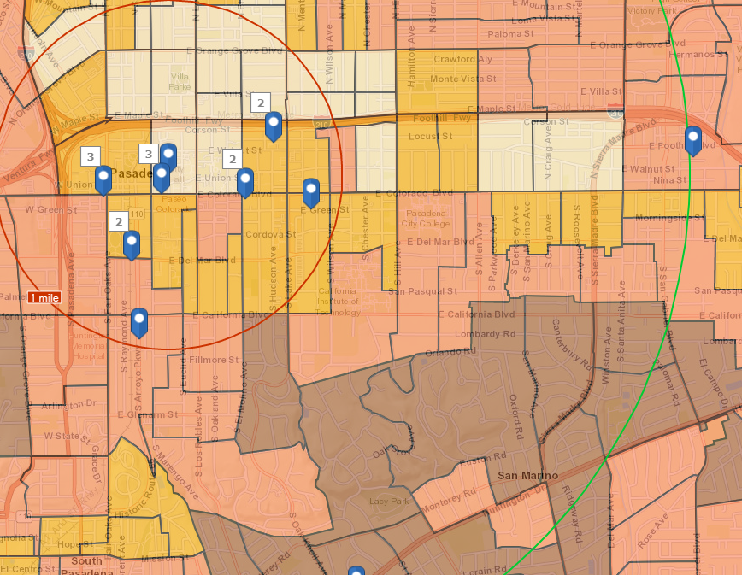

**Location Analytics III—**

**Location Analytics IV—**

**Location Analytics V—**

**Location Analytics VI—**

**Marketing Strategy—**

**Messaging Strategy—**

**Profitability—**

**Conclusion—**

**Three Wows—**

**Stores a bit of information**

**Location: *Pasadena***

Altadena Watch Co—Repair and services for watch and Jewelry-- sales volume $837,000

Jewels by Rochella—No on google maps nor information regarding about them-- sales volume $558000

Pasadena Jewelry—sales volume $558,000-

Valia’s Jewelers--Repair and custom-design, also watch repairs—Buy jewelry and antiques…resellers. -- sales volume $837000—( <https://valiasjewelers.com/>)

Bassano Jewelry—25 yrs. old store—BAO shows it on the map, but website shows Manhattan-- sales volume $274,000

Pugster Inc—Cheap jewelry—Sales Volume $6,972,00—Site doesn’t work well as of now (<http://www.pugster.com/>)

La Memoire Fine Jewelers— Sales Volume $279,000—more into the expensive type jewelry (need more research)

Rainbow Jewelry-- Sales Volume $97,000

**Not in BAO.Arcgis**

Minassian Jewelers—Private store-single business location-1994-